# Pareto Analysis

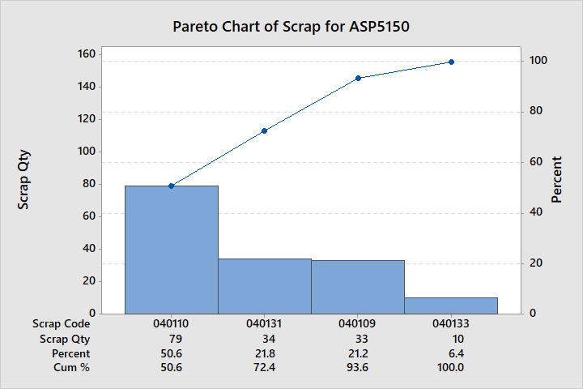

A spreadsheet was provided containing details on the occurrence of scrap. It contains the time and date of the scrap occurring, the ‘scrap code’ which refers to the reason for the scrap, as well as the quantity of scrap and how many times it has occurred. The spreadsheet covered a timeframe of 03/07/2017 to 18/01/2018; approximately a 7 month period of time.

A Pareto chart was created from the provided scrap data. It is clear from the graph that the most scrap comes from ‘040110’ which is referred to as ‘Setup Scrap’ by Unipart. This accounted for over half of all scrap (50.6%) produced in the 7 month period. Hence this should be prioritised when making improvements in order to reduce scrap; however it is first important to determine what ‘Setup Scrap’ is and where it occurs.

The second largest scrap is caused by ‘040131’ or ‘Ripples on Tube’, causing 21.8% of scrap. This is still a significant proportion of scrap, and accounted for most of the scrap pipes observed when visiting the factory floor.

The third largest scrap is caused by ‘040109’ or ‘Incorrectly Bent’, causing 21.2% of scrap. This causes roughly an equal quantity of scrap as the ripples on tube.

The smallest scrap is caused by ‘040133’ or ‘Machine Issues’. This accounted for a significantly smaller percentage of overall scrap (6.4%) and while it should be considered, it is of less importance as the above scrap causes, as it produces a fraction of the scrap compared to the aforementioned others.

One issue is that the Unipart scrap codes are not necessarily descriptive, as ‘Machine Issues’ for example does not specify the machine that was causing the problem, or the issue itself. Hence it was necessary to discuss the sources of scrap with Unipart employees to gain a better insight.

An alternative way to analyse scrap using a Pareto chart is to look at the cost of scrap rather than the quantity of scrap. Whilst ‘Setup Scrap’ may have the largest quantity, it may have a smaller cost than other types of scrap, for example. The aim of reducing scrap is to reduce cost, so this is a better indicator of which scrap causing processes should be targeted most when making improvements.